CLIENT | TP-OTC | PROJECT | SAKARYA GAS FIELD DEVELOPMENT PROJECT PHASE 3
JOB | 033781 | PURCHASE ORDER | 1534963 dtd. 21.10.2025
VENDOR / PLACE | TENARIS GLOBAL SERVICES AND INVESTMENTS S.A.R.L | VENDOR JOB NUMBER | 1534963 dtd. 21.10.2025
SUB-VENDOR / PLACE | Tenaris Confab / Brazil  Av. Gastão Vidigal Neto, 475 – Pindamonhangaba – SP - Brasil | SUB-VENDOR JOB NUMBER | N/A Yet
TYPE OF MATERIAL | 3LPP COATING of OD 609.6mm X WT 32.2mm DNV 450 FSDU
RULES AND CODES | DNV-ST-F101
SPECIFICATIONS AND DRAWINGS | SC26-3-WOR-GEP-FL-SPC- 001018_R02

IDS  Inspection Data sheet | X | Not To Be Issued |  | To Be Issued |  | Issued
Pre inspection meeting (PIM) | X | Already Held |  | To Be Planned |  | Not To Be Held
Type of inspection | X | Pre Inspection Visit |  | Construction Inspection
Partial
(of whole PO)
 | X | Intermediate Test |  | Acceptance Test
Balance
(of whole PO)
Last Inspection | X | Yes |  | No

MATERIAL / DESCRIPTION / REF. DOCUMENTS | TYPE OF TEST | W (1) | RESULT | ISSUED DOCUMENTS  (2)
3LPP COATING OD 609.6mm X WT 32.2mm DNV 450 FSDU | PQT & Early Pipes | N/A | Approved with comments | N/A

NOTES: Please, note that there are no Areas of Concern during this week

ATTENDEES:

Organization | NAME OF ATTENDEES
IQS | Pedro Eugenio
IQS | Luiz Fernando S. Mello
IQS | Marcos Tulio
IQS | Mateus Laranjeira
IQS | Carlos Henrique
Saipem | Innes Mullen
RINA | Nilson Coutinho
RINA | Aruã Pelissario
TP OTC | Jose Patricio Monteiro
Tenaris Confab | Felipe Cunha
Tenaris Confab | Normando Cunha
Tenaris Confab | Fabio Arroyo
Tenaris Confab | Bruna Pereira
NOTES: Yes
Any comments for this report

SCOPE OF INSPECTION:
description | result
3LPP Coating Mill PQT and Early Pipes Production | ONGOING

DOCUMENT USED:
document used | Doc. number | rev. | issue date
ITP | SC26-3-CNF-GEP-MN-ITP-707024 | 02 | 15/10/2025

DETAILS OF INSPECTION AND TEST INSTRUMENTS USED:
equipment name | manufacturer | S/N | next CALIBRATION
All the Instruments and equipments used during this weekly qualification/production were noted with valid calibration date.

ATTACHMENTS:
DESCRIPTION | TYPe | PAGEs
3LPP PQT SAKARYA TABLE CONTROL 06.19.2026 | EXCEL TABLE | 8

Details and results of inspection:

M A T E R I A L I N S P E C T E D |  | Q U A N T I T Y (PCS)
ITEM NO | BRIEF DESCRIPTION | TOTAL ORDER | PRESENTED | ACCEPTED | Previously accepted
1 | DNV SAWL 450 SFDU - External 3LPP coating (+ rough coat)- Pipes for Onshore Route | 1525 | 0 | 0 | 0
2 | DNV SAWL 450 SFDU - External 3LPP coating (+ rough coat) - Pipes for Onshore FJC PQT + PPT | 0 | 0 | 0 | 0
3 | DNV SAWL 450 SFDU - External 3LPP coating + rough coat - Pipes for Route R6 + Wet Buckle Contingency SEE GENERAL REMARKS FOR DETAILS RELATED TO REQUIRED DELIVERY DATE | 186562.4 | 0 | 0 | 0
4 | DNV SAWL 450 SFDU - External 3LPP coating + rough coat - Pipes for Installation A/R tail / Dummy string | 0 | 0 | 0 | 0
5 | DNV SAWL 450 SFDU - External 3LPP coating + rough coat - Pipes for Equip. Calib + Tests (Frict + Fat) | 12.2 | 0 | 0 | 0
6 | DNV SAWL 450 SFDU - External 3LPP coating + rough coat with 50 mm CWC | 0 | 0 | 0 | 0
7 | DNV SAWL 450 SFDU - External 3LPP coating + rough coat with 120 mm CWC | 0 | 0 | 0 | 0
8 | DNV SAWL 450 SFDU - Bare - Pipes ONSHORE DIV SPOOL | 12.2 | 12,43 M | 12,43 M | 0
9 | DNV SAWL 450 SFDU - Bare - Pipes for Installation and Precom Heads | 48.8 | 49,33 M | 49,33 M | 0
10 | DNV SAWL 450 SFDU - Bare - Pipes for Contractor Offshore (PTC) WPQT – For Welding Laboratory | 122 | 124,07 M | 124,07 M | 0
11 | DNV SAWL 450 SFDU - Bare - Pipes for Contractor Onshore WPQT – For Welding Laboratory | 48.8 | 49,16 M | 49,16 M | 0
12 | DNV SAWL 450 SFDU - Bare - Pipes for Contractor WPQT – For Welding Vessel (Lay Vessel) | 292.8 | 0 | 0 | 0
13 | DNV SAWL 450 SFDU - External 3LPP coating + rough coat - Pipes for Offshore FJC PQT + PPT - SLOTTED (9-OFF SLOTS, PTC) NOTE: slots on 3LPP shall be prepared to simulate field joint coating, each slot has width 340 -0/+40mm (double cutback), FBE tail 3-10m | 109.8 | 0 | 0 | 0
14 | DNV SAWL 450 SFDU - External 3LPP coating + rough coat with 50 mm CWC - Pipes for Offshore FJC PQT + PPT - SLOTTED (7-OFF SLOTS, PTC) NOTE: slots on CWC shall be prepared to simulate field joint coating, each slot has width 740 -0/+40mm (double cutback), | 0 | 0 | 0 | 0
15 | DNV SAWL 450 SFDU - External 3LPP coating + rough coat with 120 mm CWC - Pipes for Offshore FJC PQT + PPT - SLOTTED (7-OFF SLOTS, PTC) NOTE: slots on CWC shall be prepared to simulate field joint coating, each slot has width 740 -0/+40mm (double cutback), | 0 | 0 | 0 | 0
16 | DNV SAWL 450 SFDU - Bare - Pipes for Offshore BA FJC PQT + PPT - SLOTTED (9-OFF SLOTS, PTC) NOTE: to be supplied bare | 0 | 0 | 0 | 0
17 | ON 50MM CWC (5pcs) | 0 | 0 | 0 | 0
18 | CWC (11PCS) | 1 | 0 | 0 | 0
19 | (675 pcs) | 1 | 0 | 0 | 0
20 | TBD | 1 | 0 | 0 | 0
21 | DNV SAWL 450 SFDU - EXTERNAL 3LPP COATING + ROUGH COAT - Pipes for Onshore FJC - SLOTTED (3LPP, 9-off SLOTS, to Subcontractor onshore) NOTE: SLOTS ON 3LPP SHALL BE PREPARED TO SIMULATE FIELD JOINT COATING, EACH SLOT HAS WIDTH 340 -0/+40MM (DOUBLE CUTBACK) | 36.6 | 0 | 0 | 0
22 | DNV SAWL 450 SFDU - BARE Pipes for Onshore (future use: FJC - SLOTTED FSPP, 9-off SLOTS, to Subcontractor onshore) NOTE: TO BE SUPPLIED BARE | 36.6 | 36,87 M | 36,87 M | 0
23 | DNV SAWL 450 SFDU - External 3LPP coating + rough coat with 70 mm CWC | 1976.4 | 0 | 0 | 0
24 | DNV SAWL 450 SFDU - Bare Pipes for MIJ | 12.2 | 11,83 M | 11,83 M | 0
25 | DNV SAWL 450 SFDU - Bare Pipes for PLET Piping (no Bends, HOP solution) | 12.2 | 12,34 M | 12,34 M | 0
26 | DNV SAWL 450 SFDU - External 3LPP coating + rough coat Pipes for compatibility test with FJC SLOTTED (9 -OFF SLOTS, PTC) NOTE: SLOTS ON 3LPP SHALL BE PREPARED TO SIMULATE FIELD JOINT COATING, EACH SLOT HAS WIDTH 340 -0/+40MM (DOUBLE CUTBACK), FBE TAIL 3-1 | 12.2 | 0 | 0 | 0
27 | DNV SAWL 450 SFDU - Spare - EXTERNAL 3LPP COATING + ROUGH COAT - Pipes for Offshore FJC - NOT SLOTTED, PTC) | 48.8 | 0 | 0 | 0
28 | DNV SAWL 450 SFDU - Spare - EXTERNAL 3LPP COATING + ROUGH COAT - Pipes for Offshore FJC + CWC 70mm - SLOTTED (7-OFF SLOTS, PTC) - ONLY ONE CWCT NOTE: SLOTS ON CWC SHALL BE PREPARED TO SIMULATE FIELD JOINT COATING, EACH SLOT HAS WIDTH 740 -0/+40MM (DOUBLE | 48.8 | 0 | 0 | 0
29 | DNV SAWL 450 SFDU - Spare - Bare PLET Piping for PLET Yard - Welding qualification and welder qualifications | 85.4 | 86,51 M | 86,51 M | 0
30 | TBD | 12.2 | 12,43 M | 12,43 M | 0
31 | TBD | 12.2 | 12,30 M | 12,30 M | 0
32 | TBD | 12.2 | 12,23 M | 12,23 M | 0
33 | TBD | 24.4 | 24,48 M | 24,48 M | 0
34 | DAP DELIVERY | 1 | 0 | 0 | 0
35 | PLANT MODIFICATION | 1 | 0 | 0 | 0

3LPP Coating Mill PQT and Early Pipes Production

As per SC263-SPM-CNF-NOI-004 Rev.4, the 3LPP PQT, as per QCP No.: 50217-3LPP-PQT Rev.08, following the sequence.

3LPP EARLY BATCH

- Rough Coat Repair for 3LPP PQT pipes.
Tenaris is conducting the rough coat repair (Repair Type 3). The repair will be performed in all PQT pipes in areas with missing rough coat (three unroughened areas). Tenaris will follow the steps cleaning the surface using a cloth and solvent to remove contaminants and use the Bristle blasting in accordance with the manufacturer’s recommendations, resulting in a uniform surface texture. The activity will take place 3 shifts.

As per SC263-SPM-CNF-NOI-004 Rev.4, the 3LPP PQT, as per QCP No.: 50217-3LPP-PQT Rev.08, following the sequence.

ONLINE TEST ON 3LPP - EARLY BATCH – PEEL STRENGTH TEST

Tenaris performed Peel Strength Tests in 9 pipe (PST) on the early batch, as the cutback operation was completed prior to the execution of the tests. Upon completion of the PST, the affected pipe ends will be cut to remove the areas opened during testing. Subsequently, a new cutback operation will be performed, followed by the applicable Non-Destructive Testing (NDT) inspections to verify compliance with project requirements.

Peel Strength (N/mm)
Pipe number | End A / B |  |  |  |  |  |  |  | Type of failure |  |  | Remarks
Pipe number | Position | Temp (°C) | Kgf  Ave. | N/mm  Ave. | Kgf  Min. | N/mm  Min. | Kgf  Max. | N/mm  Max. | Adhesive | Cohesive | Elongation PP | Remarks
26.4. 2116 | END A | 22,71 | 127,34 | 49,97 | 69 | 27,08 | 167 | 65,53 | 0% | 90% | 10% | Cohesive mode + Elongation
26.4. 2116 | END A | 88,99 | 68,65 | 26,94 | 62 | 24,33 | 77 | 30,21 | 0% | 100% | 0% | Cohesive mode
26.4. 2116 | END B | 24,92 | 130,4 | 51,17 | 61 | 23,94 | 196 | 76,91 | 0% | 90% | 10% | Cohesive mode + Elongation
26.4. 2116 | END B | 88,82 | 85,54 | 33,57 | 75 | 29,43 | 96 | 37,67 | 0% | 100% | 0% | Cohesive mode

Peel Strength (N/mm)
Pipe number | End A / B |  |  |  |  |  |  |  | Type of failure |  |  | Remarks
Pipe number | Position | Temp (°C) | Kgf  Ave. | N/mm  Ave. | Kgf  Min. | N/mm  Min. | Kgf  Max. | N/mm  Max. | Adhesive | Cohesive | Elongation PP | Remarks
26.4. 2150 | END A | 23,34 | 126,45 | 49,62 | 118 | 46,30 | 140 | 54,94 | 0% | 100% | 0% | Cohesive mode
26.4. 2150 | END A | 89,32 | 78,47 | 30,79 | 71 | 27,86 | 87 | 34,14 | 0% | 100% | 0% | Cohesive mode
26.4. 2150 | END B | 23,65 | 131,31 | 51,53 | 109 | 42,77 | 151 | 59,25 | 0% | 100% | 0% | Cohesive mode
26.4. 2150 | END B | 89,29 | 85,66 | 33,61 | 79 | 31,00 | 94 | 36,89 | 0% | 100% | 0% | Cohesive mode

Peel Strength (N/mm)
Pipe number | End A / B |  |  |  |  |  |  |  | Type of failure |  |  | Remarks
Pipe number | Position | Temp (°C) | Kgf  Ave. | N/mm  Ave. | Kgf  Min. | N/mm  Min. | Kgf  Max. | N/mm  Max. | Adhesive | Cohesive | Elongation PP | Remarks
26.4. 2163 | END A | 24,15 | 160,86 | 63,12 | 87 | 34,14 | 208 | 81,62 | 0% | 100% | 0% | Cohesive mode
26.4. 2163 | END A | 89,49 | 97,08 | 38,09 | 85 | 33,35 | 106 | 41,59 | 0% | 100% | 0% | Cohesive mode
26.4. 2163 | END B | 25,4 | 190,81 | 74,87 | 159 | 62,39 | 210 | 82,40 | 0% | 90% | 10% | Cohesive mode + Elongation
26.4. 2163 | END B | 89,4 | 93,7 | 36,77 | 80 | 31,39 | 102 | 40,02 | 0% | 100% | 0% | Cohesive mode

Peel Strength (N/mm)
Pipe number |  |  |  |  |  |  |  |  | Type of failure |  |  | Remarks
Pipe number | Position | Temp (°C) | Kgf  Ave. | N/mm  Ave. | Kgf  Min. | N/mm  Min. | Kgf  Max. | N/mm  Max. | Adhesive | Cohesive | Elongation PP | Remarks
26.4. 2188 | END A | 24,45 | 121,23 | 47,57 | 102 | 40,02 | 177 | 69,45 | 0% | 100% | 0% | Cohesive mode
26.4. 2188 | END A | 89,10 | 80,84 | 31,72 | 70 | 27,47 | 91 | 35,71 | 0% | 100% | 0% | Cohesive mode
26.4. 2188 | END B | 23,9 | 148,22 | 58,16 | 138 | 54,15 | 162 | 63,57 | 0% | 100% | 0% | Cohesive mode
26.4. 2188 | END B | 89,27 | 86,02 | 33,75 | 72 | 28,25 | 97 | 38,06 | 0% | 100% | 0% | Cohesive mode

Peel Strength (N/mm)
Pipe number |  |  |  |  |  |  |  |  | Type of failure |  |  | Remarks
Pipe number | Position | Temp (°C) | Kgf  Ave. | N/mm  Ave. | Kgf  Min. | N/mm  Min. | Kgf  Max. | N/mm  Max. | Adhesive | Cohesive | Elongation PP | Remarks
26.4. 2109 | END A | 23,11 | 134,12 | 52,63 | 58 | 22,76 | 221 | 86,72 | 0% | 90% | 10% | Cohesive mode + Elongation
26.4. 2109 | END A | 88,21 | 80,54 | 31,60 | 64 | 25,11 | 97 | 38,06 | 0% | 100% | 0% | Cohesive mode
26.4. 2109 | END B | 22,16 | 133,54 | 52,40 | 106 | 41,59 | 153 | 60,04 | 0% | 100% | 0% | Cohesive mode
26.4. 2109 | END B | 89,19 | 72,43 | 28,42 | 63 | 24,72 | 79 | 31,00 | 0% | 100% | 0% | Cohesive mode

Peel Strength (N/mm)
Pipe number |  |  |  |  |  |  |  |  | Type of failure |  |  | Remarks
Pipe number | Position | Temp (°C) | Kgf  Ave. | N/mm  Ave. | Kgf  Min. | N/mm  Min. | Kgf  Max. | N/mm  Max. | Adhesive | Cohesive | Elongation PP | Remarks
26.4. 2201 | END A | 23,11 | 133,55 | 52,41 | 88 | 34,53 | 213 | 83,58 | 0% | 90% | 10% | Cohesive mode + Elongation
26.4. 2201 | END A | 89,10 | 72,35 | 28,39 | 61 | 23,94 | 85 | 33,35 | 0% | 100% | 0% | Cohesive mode
26.4. 2201 | END B | 23,87 | 150,69 | 59,13 | 135 | 52,97 | 179 | 70,24 | 0% | 100% | 0% | Cohesive mode
26.4. 2201 | END B | 89,51 | 91,5 | 35,90 | 74 | 29,04 | 102 | 40,02 | 0% | 100% | 0% | Cohesive mode

Peel Strength (N/mm)
Pipe number |  |  |  |  |  |  |  |  | Type of failure |  |  | Remarks
Pipe number | Position | Temp (°C) | Kgf  Ave. | N/mm  Ave. | Kgf  Min. | N/mm  Min. | Kgf  Max. | N/mm  Max. | Adhesive | Cohesive | Elongation PP | Remarks
26.4. 2146 | END A | 24,39 | 132,18 | 51,87 | 75 | 29,43 | 189 | 74,16 | 0% | 100% | 0% | Cohesive mode
26.4. 2146 | END A | 88,87 | 76,82 | 30,14 | 70 | 27,47 | 83 | 32,57 | 0% | 100% | 0% | Cohesive mode
26.4. 2146 | END B | 22,68 | 157,68 | 61,87 | 84 | 32,96 | 208 | 81,62 | 0% | 90% | 10% | Cohesive mode + Elongation
26.4. 2146 | END B | 87,20 | 86,15 | 33,81 | 78 | 30,61 | 96 | 37,67 | 0% | 100% | 0% | Cohesive mode

Peel Strength (N/mm)
Pipe number |  |  |  |  |  |  |  |  |  | Type of failure |  |  |  | Remarks
Pipe number | Position | Temp (°C) | Kgf  Ave. | N/mm  Ave. | Kgf  Min. | N/mm  Min. | Kgf  Max. | N/mm  Max. | Adhesive |  | Cohesive | Elongation PP | Remarks
26.4. 2187 | END A | 23,70 | 146,68 | 57,56 | 79 | 31,00 | 202 | 79,26 | 0% |  | 90% | 10% | Cohesive mode + Elongation
26.4. 2187 | END A | 88,55 | 75,87 | 29,77 | 63 | 24,72 | 94 | 36,89 | 0% |  | 100% | 0% | Cohesive mode
26.4. 2187 | END B | 23,59 | 156,38 | 61,36 | 130 | 51,01 | 198 | 77,70 | 0% |  | 100% | 0% | Cohesive mode
26.4. 2187 | END B | 89,13 | 86,67 | 34,01 | 80 | 31,39 | 94 | 36,89 | 0% |  | 100% | 0% | Cohesive mode

Peel Strength (N/mm)
Pipe number |  |  |  |  |  |  |  |  | Type of failure |  |  | Remarks
Pipe number | Position | Temp (°C) | Kgf  Ave. | N/mm  Ave. | Kgf  Min. | N/mm  Min. | Kgf  Max. | N/mm  Max. | Adhesive | Cohesive | Elongation PP | Remarks
26.4. 2236 | END A | 20,3 | 157,21 | 61,69 | 123 | 48,27 | 191 | 74,95 | 0% | 90% | 10% | Cohesive mode + Elongation
26.4. 2236 | END A | 89,18 | 73,94 | 29,01 | 62 | 24,33 | 82 | 32,18 | 0% | 100% | 0% | Cohesive mode
26.4. 2236 | END B | 22,25 | 149,93 | 58,83 | 138 | 54,15 | 159 | 62,39 | 0% | 100% | 0% | Cohesive mode
26.4. 2236 | END B | 87,70 | 101,43 | 39,80 | 92 | 36,10 | 116 | 45,52 | 0% | 100% | 0% | Cohesive mode

Note 1: When the type of failure is registered as “Elongation” the PST test should be interrupted and the maximum force will be considered as reference value.
Note 2: The peel strength tests performed today up to the execution of this report were satisfactory.

Acceptance criteria
Temperature: | 23±3°C | Force: | 63.71Kgf | 25N/mm
 | Absolute minimum Force: |  | 50.96Kgf | 20N/mm
Temperature: | 90±3°C | Force: | 15.29Kgf | 6N/mm
 | Absolute minimum Force: |  | 10.70Kgf | 4.2N/mm
Peel strength acceptance criteria

PTS TESTS EARLY BATCH
TOTAL OF TESTS PROGRAMED | 36
TOTAL OF TESTS PERFORMED | 36
REMAINING TESTS | 00

OFFLINE TEST ON 3LPP - EARLY BATCH – PEEL STRENGTH TEST

- NCR-006: Elongation at Break (≥ 400%) and Tensile Strength (˃20MPa) Pipe N° 26.4.2148:
The retest was performed as per applicable specification and approved with an average of 25.12MPa and 651%. The full value will be shared in the weekly table.

Note: First sample discarded due to previous rupture outside the strain gauge area.

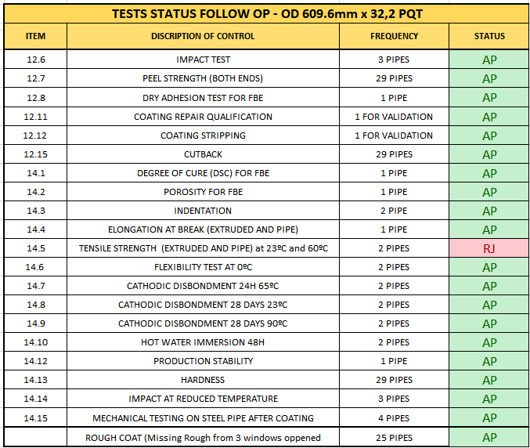

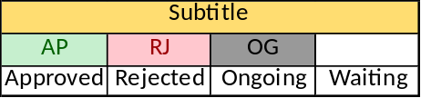

Areas of Concern:
There are no comments about this weekly visit

PHOTOGRAPHS

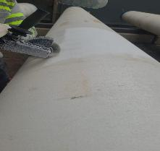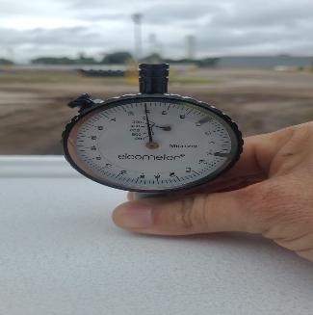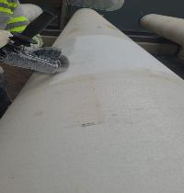
Rough coat repair from PQT pipes

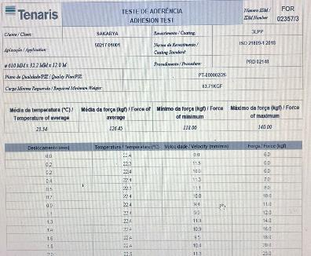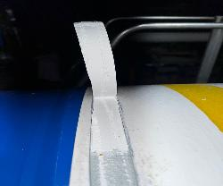
Peel strength test at 90ºC – Early batch

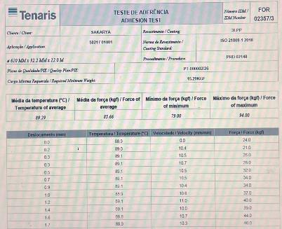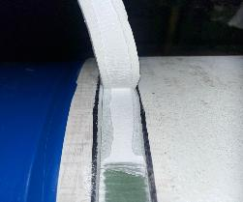
Peel strength test at 90ºC – Early batch

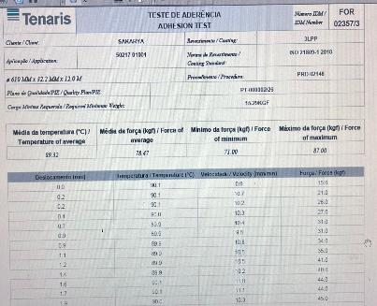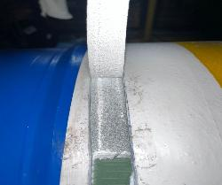
Peel strength test at 90ºC – Early batch

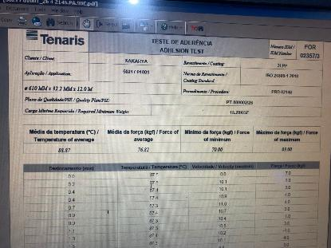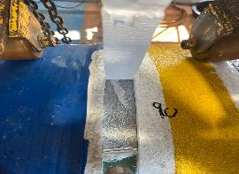
Peel strength test at 90ºC – Early batch

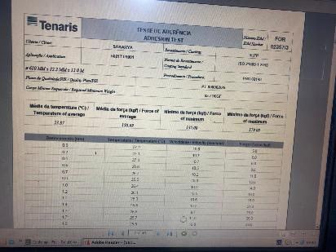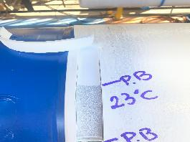
Peel strength test at 23ºC – Early batch

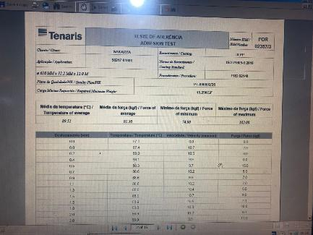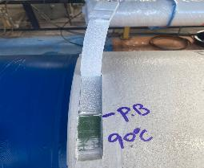
Peel strength test at 90ºC – Early batch

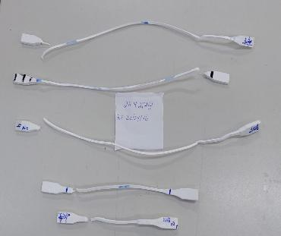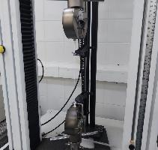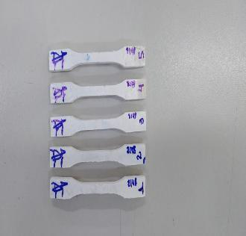
Retest Elongation and tensile strength test Pipe 26.4.2148

End of this Report

